PAIGE

CONNECT

User manual

Paige Connect logo.

# INTRODUCTION

Paige Connect is an adaptation for braille writers which records key presses and displays the instantaneous translation on an accompanying web app on a phone, tablet, or laptop. It enables collaboration with sighted peers, parents, and teachers.

Paige Connect transforms your classic Perkins braille writer* into a Bluetooth keyboard. This makes it compatible with any software that accepts SDFJKL braille input.

## What’s in the box?

Paige Connect board: model v1

Power cable: Type A Plug to DC Barrel Plug 2.5 x 5.5 mm

Contact us at [hello@paigebraille.com](mailto:hello@paigebraille.com) if any items are missing or damaged.

*Our product is not manufactured or endorsed by Perkins School for the Blind and Paige Braille is not affiliated with Perkins School for the Blind in any way.

SAFETY AND WARNINGS Warning sign

The safety of any system incorporating this equipment is the responsibility ofthe assembler of the system.

Only use a USB power adapter / computer USB port to power Paige Connect. Using other power supplies can cause an overheating hazard.

If the equipment is used in any manner not specified by the manufacturer the protection provided by the equipment might be impaired.

We DO NOT recommend modifying Paige Connect or its original accessories, like the power cable. Only accessories which meet the manufacturer’s specifications shall be used.

# SWAP

## Step 1

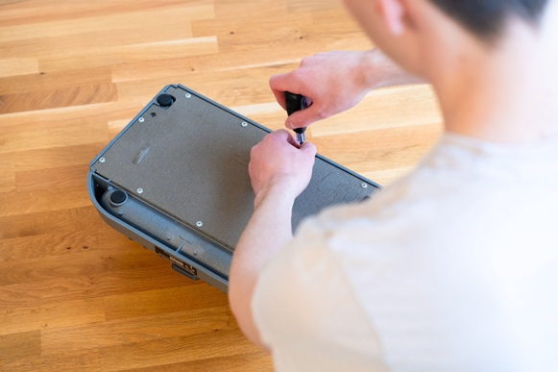

Unscrew the base of your braille writer.

## Step 2

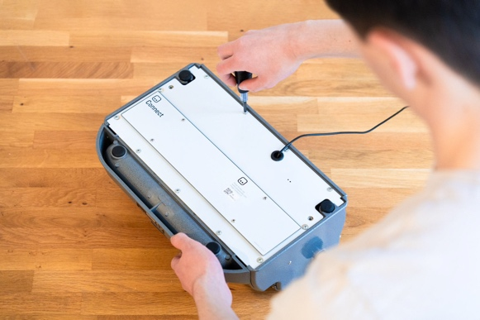

Replace it with the Paige Connect board. Before tightening the screws move the board side to side until it is positioned so that the space key can lower fully.

## Step 3

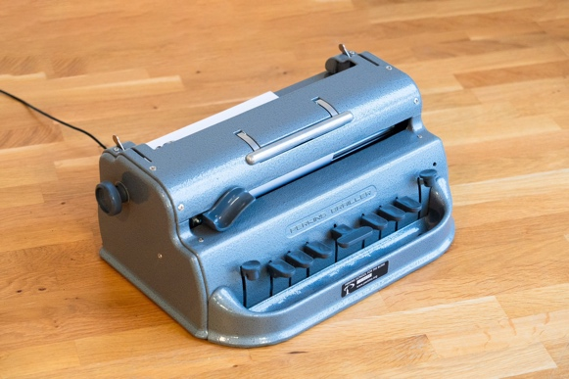

Plug in the USB cable.

# TRANSLATE

## Step 1



On your phone, tablet or laptop, turn Bluetooth on and pair with Paige Connect.

## Step 2

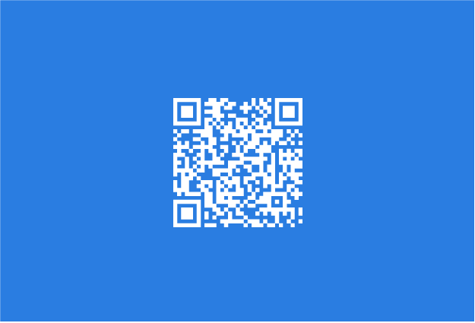

Go to our website at [paigebraille.com/translate](https://paigebraille.com/translate).

## Step 3

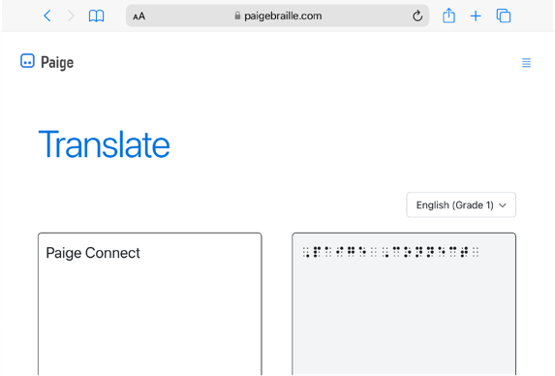

Start writing braille to see or hear what you emboss!

# LEARN

## Step 1



On your phone, tablet or laptop, turn Bluetooth on and pair with Paige Connect.

## Step 2

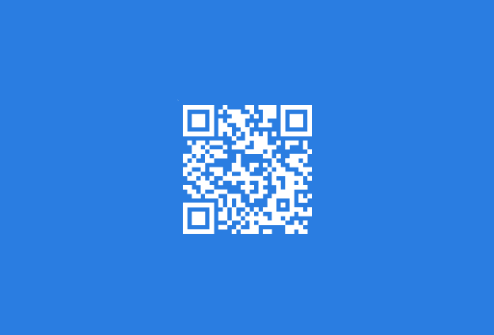

Go to our website at [paigebraille.com/learn](https://paigebraille.com/learn).

## Step 3

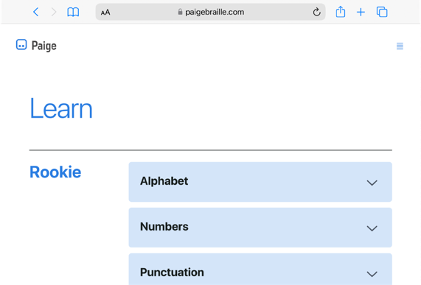

Start learning braille with curated online exercises!

# SPECIFICATION

## Mechanical characteristics

Model: v1

Weight: 0.2 kg

Size: 335.75 x 175 mm

Cable length: 1 m

## Electrical characteristics

Power supply requirements: 5V (DC), Min. 0.5A. Examples: USB power socket, laptop.

## Environmental conditions for use

Temperature: 5 °C to 40 °C

Humidity: < 80% RH

Altitude: < 2000 m

## Safety compliance information

Degree of protection IEC-60529: IPX0

Pollution degree: 2

## Symbols

DC Power symbol DC Power supply

 Polarity symbol. Indicates the centre (or tip) of the output plug is positive.

# SPECIFICATION

## Maintenance

Once Paige Connect is installed it remains protected from the outside world. However, dust, dirt, and oil can accumulate inside your braille writer over time and affet its performance.

To avoid these problems we recommend covering your braille writer with a dist cover en it is not being used and keep food and drinks away from it.

To clean Paige Connect make sure to unplug it first and use a dry and soft cloth.

### Spare parts list

Power cable: Type A Plug to DC Barrel Plug 2.5 x 5.5 mm

No user serviceable parts inside, please contact us at [hello@paigebraille.com](mailto:hello@paigebraille.com) for service, repair and to purchase spare parts.

## Recycling

Please do not dispose of Paige Connect in regular bins. Recycle electronic devices free at your local recycling centre. Search for your nearest recycling centre at [www.recyclenow.com.](http://www.recyclenow.com/)

Many electrical components can be repaired or recycled, saving natural resources and the environment.

## Markings

FCC, UKCA, CE, and WEEE markings

If you have any questions, get in touch at [hello@paigebraille.com](mailto:hello@paigebraille.com) or visit our website at [www.paigebraille.com](http://www.paigebraille.com) for more help.

# CONTACT US AT

hello@paigebraille.com

[www.paigebraille.com](http://www.paigebraille.com)

© Paige Braille Ltd